Lenz’s Law Activity Instructor Guide

Activity Overview
Lenz’s law states that the direction of the electric current induced in a conductor by a changing external (applied) magnetic field is such that the magnetic field sourced by the induced current (“the induced magnetic field”) opposes changes in the flux associated with the externally applied magnetic field.
In this activity, each student will be given one of four roles:
- E: Electrons
- C: Current (these are to emphasize the fact that the conventional current points in the opposite direction as the electron flow).
- EM: External/Applied Magnetic Field
- IM: Induced Magnetic Field
Each of these students should have something to represent their role, such as the signs below, which can be printed out (a pdf of the signs can be found in the supplemental materials). If possible (depending on the size of your class), it is beneficial to rotate between these four roles so that everyone plays each role at least once during the activity.
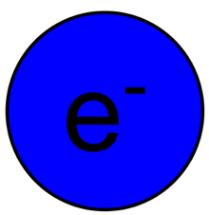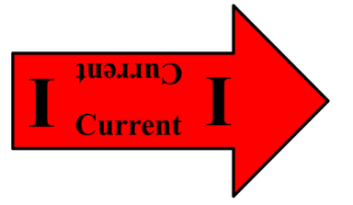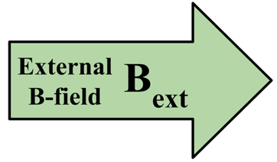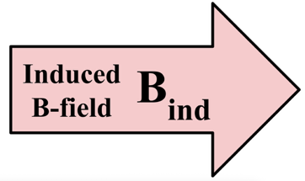
In an open space in your classroom (or outside), mark a large circle on the floor (e.g. using blue tape or chalk, if outside). This circle will represent a conducting wire. The electrons will stand on the wire and walk around the circle in the appropriate direction, given the scenario. The students representing the current will stand back slightly and hold their arrows or point to indicate the direction of the conventional current. The magnetic fields will stand inside or outside the circle, depending on the scenario (so be sure your circle is big enough).
Various scenarios for different types of applied magnetic fields will then be presented to the students, who will have to work as a team to decide the resulting effects and then act them out, by walking around the room. The instructor will assist the students when needed.

Variations based on class-size
Depending on your class size, you may need to have multiple groups completing the activity. This activity has been successful in both a 12-person class and a 97-person class.
For smaller class, you may be able to get by with one group all working together. For instance, for a 12-person class, we had three students in each role and they all worked together to represent one system. In a standard classroom, this activity can likely be completed inside.
For a larger class, you will need to have multiple groups, each group working as a team to represent one physical system. Teams of around 12 students seems to be ideal. If the class is very large, then the instructor will need to consider the space. For instance, if the class is in a large lecture-hall, then they activity will need to be moved to a large open-space outside or into a large available room. For classes with multiple groups, you may add a competition element, where the groups are competing against each other, e.g. to see who can get the correct answer the fastest.

Activities

Warm-up
In order to introduce the activity, it is nice to start with a warm-up. Have the electron’s flow around the circle in either direction (all electrons flowing the same direction). The students indicating the current should then decide which direction the conventional current is flowing and point their arrows in that direction. The induced magnetic field students should then stand inside the circle and indicate the direction of the magnetic field in the loop. Then, have the induced field students move outside the loop and indicate the direction. If the instructor feels the students need further practice, they can repeat the exercise with the electrons flowing in the opposite direction.

Lenz’s Law Activities
We are now ready to consider a series of activities to investigate Lenz’s law. For all of these, the students representing the external magnetic field will be given an instruction. They will then act it out and the students with the other three roles will need to decide how they should respond. We had our students slowly stand or slowly squat to represent an increasing or decreasing magnitude of magnetic field. Here are the activities you may choose from (choosing more or less depending on your time available). For a 12-person class, where we were able to stay in the same classroom, we were able to introduce the activity, including a review of Lenz’s law, and get through all of the scenarios in 1-hour.

Instructions given to students | Answer key | Answer key
Applied Magnetic Field (inside the ring, unless directed otherwise) | Current (direction as viewed top-down) | Induced B-field
Constant field pointing upward | No induced current | No induced field
Increasing field pointing upward | Clockwise current | Induced field points down
Decreasing field pointing upward | C.C.W. current | Induced field points up
Increasing field pointing downward | C.C.W current | Induced field points up
Decreasing field pointing downward | Clockwise current | Induced field points down
Increasing field pointing upward, outside the ring (no field inside ring) | No induced current | No induced field
Increasing field pointing horizontally | No induced current | No induced field
Field with constant magnitude, starting horizontally and changing direction to ultimately point upward | Clockwise current | Induced field points down
Field with constant magnitude, starting horizontally and changing direction to point downward | C.C.W current | Induced field points up
Field with constant magnitude, starting field pointing directly up, lower your arm down until it points directly down | C.C.W current | Induced field points up
Field with constant magnitude, starting field pointing directly up, lower your arm down until it points directly down. Then, raise it back up again, until it points straight up. Repeat motion periodically. | C.C.W current as arm moves down  Clockwise current as arm moves up  AC Current! | Induced field points up as arm moves down  Induced field points down as arm moves up
As you progress through the activities, ideally the students are coming up with the answers on their own with as little input from the instructor as possible. This all will depend on where your class is in the semester and how familiar they are with Lenz’s law prior to the activity.

Reflection
Ideally, the students will be given time to reflect on the activity in some way. In both the large and small-class iterations, students did not take notes during the activity (though, there was some feedback from students that they would have liked that, so you might try to incorporate it). Instead, in the small class setting, we had sufficient time (it was a 2-hour class) to review each of the activities after the fact, so students were able to reflect and take notes.

